ISU Center of Excellence Oberstdorf – Ice Dance Tryout Seminar 2021
June 11-13

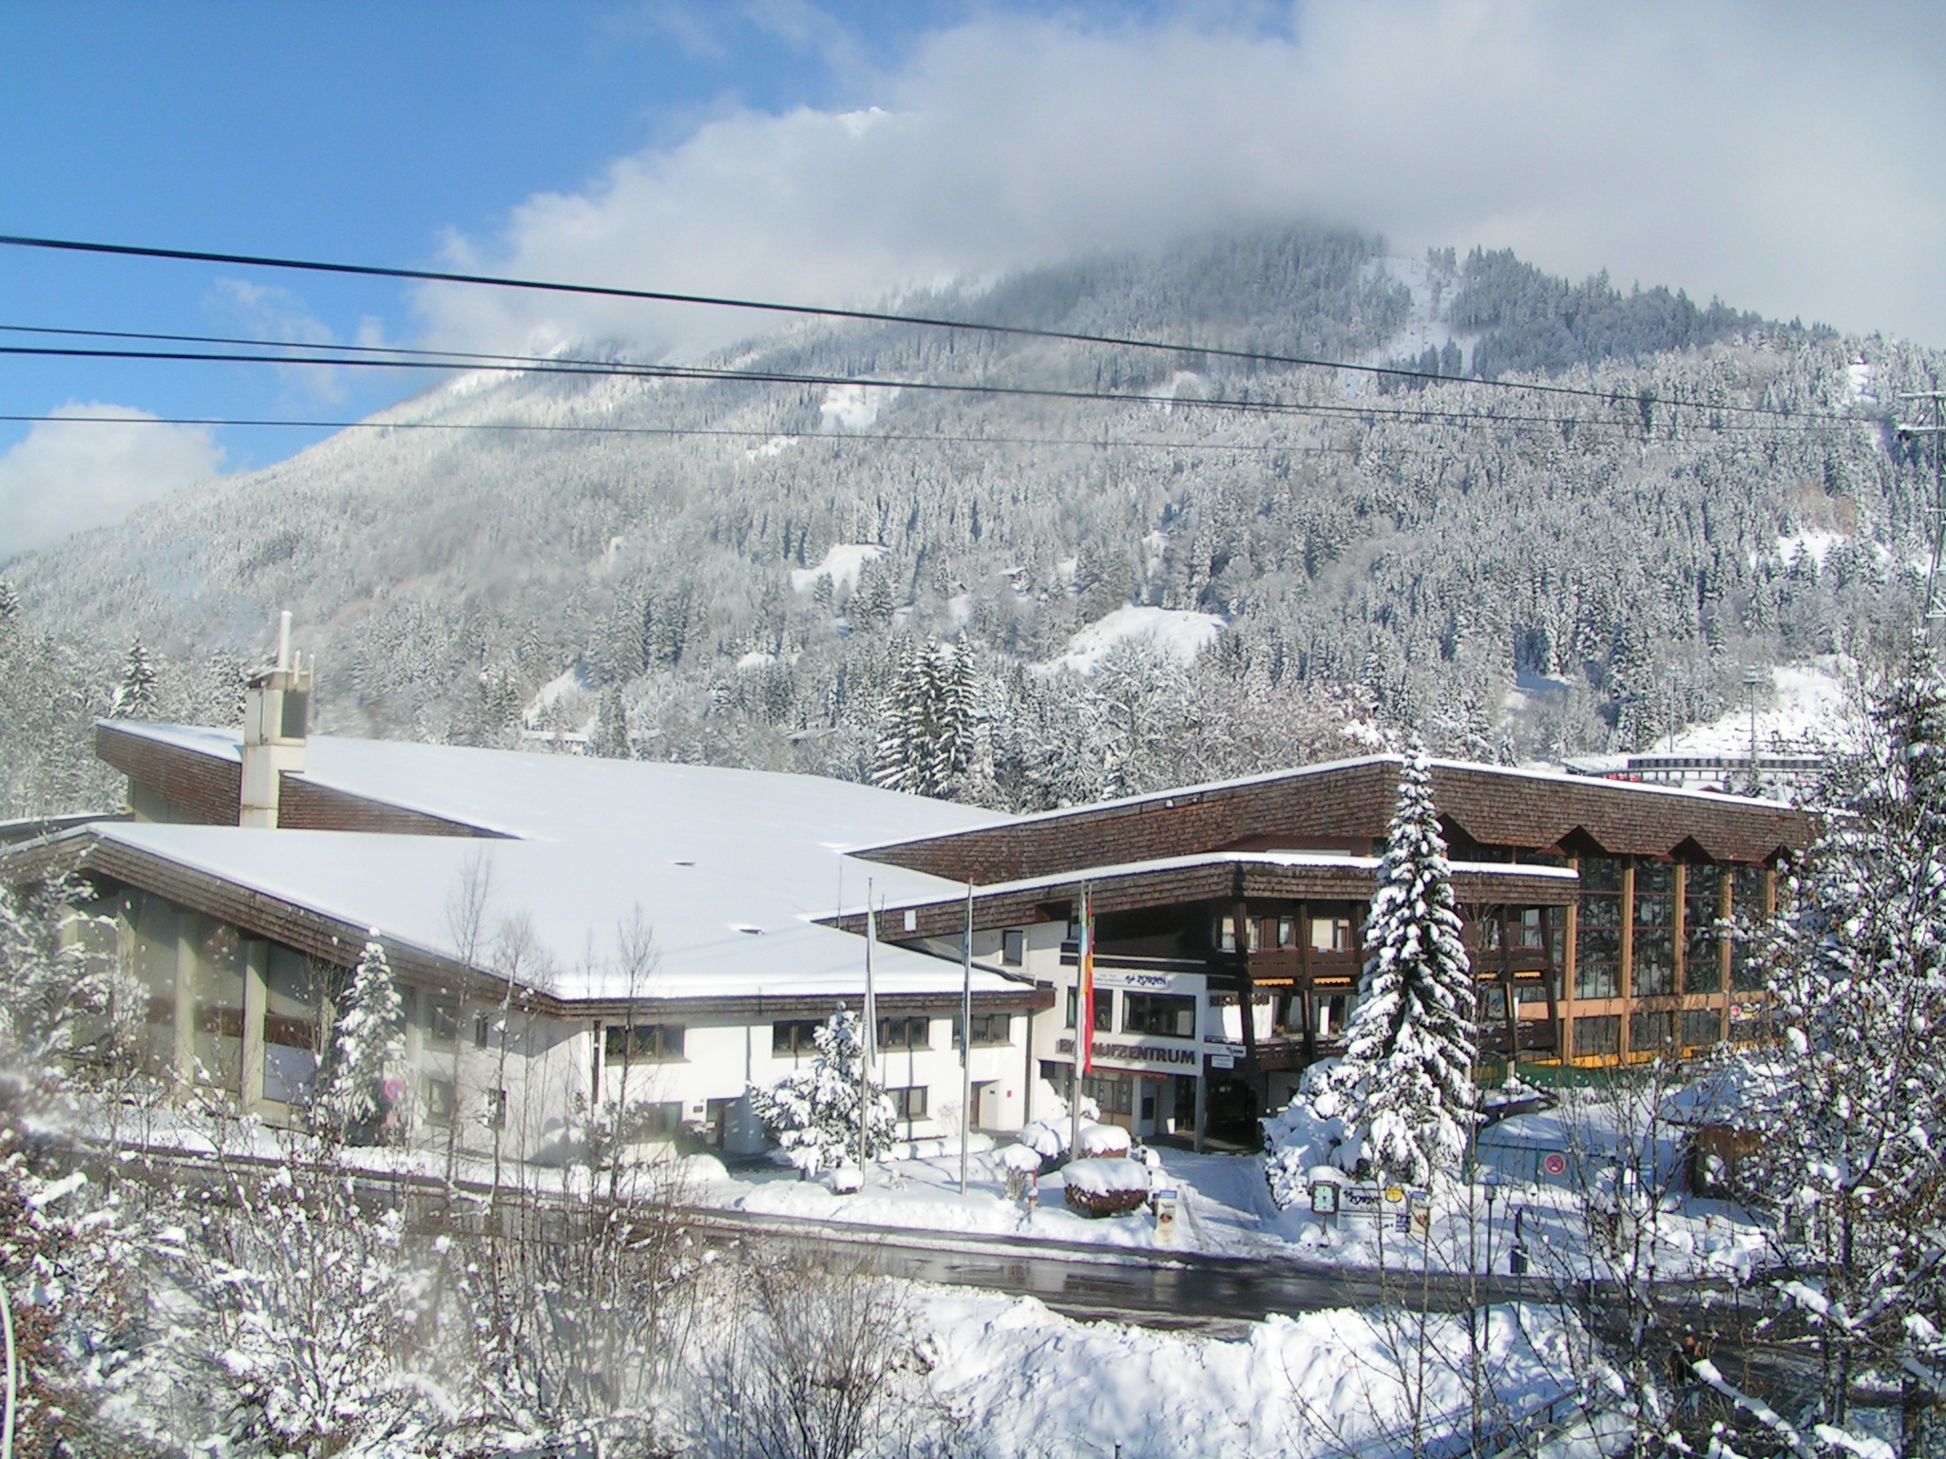
The Oberstdorf ISU Center of Excellence is holding an international Ice Dance Tryout Seminar for the first time this summer.
The 3-day seminar will be led by two internationally experienced ice dance coaches Sylwia Nowak (POL) and Dr. Rostislav Sinicyn (CZE).
The goal is to introduce ice dancing to young single skaters as an alternative career path and the formation of new ice dance teams in the future. Potentially, some international partnerships can be formed then. The focus of the training sessions will be on partnering exercises on and off the ice.
Seminar Dates
11 -13 of June 2021
(Arrival 10th of June – Departure 14th of June)
Target Group
Pre-Novice, Novice and Junior Level skaters
Training location
The ice rink in Oberstdorf has been made world famous as many international stars have benefitted and have enjoyed optimal training conditions here. The center has to offer 3 Ice Rinks under one roof, a Ballet Hall, Yoga Room, several Changing Rooms, and a Restaurant.
Eissportzentrum Oberstdorf
Roßbichlstraße 2-6
87561 Oberstdorf, Germany
Catering
Lunch and dinner are served for athletes and coaches at the Zoran Restaurant which is conveniently situated within the ice sports centre.
Course fees
The participation fee is 100€ per skater. The prize includes all coaching and facility use during the seminar.
Lunch and dinner for the participating athletes and coaches during the training days are also included (11th-13th of June).
Accomodation
Accommodation is to be paid for by the participants. A limited reservation of apartments have been made within walking distance to the ice rink and is provided by the organizer. The prices for an appartement range from 75€-130€ per night, depending on the equipment and size. Apartments are offered for 1-2 up to 5 people.
For details and bookings, please contact:
Ferienwohnungen Blattner
Bahnhofplatz 1b
87561 Oberstdorf
Mail: mail@blattner-fewo.de
Web: www.blattner-fewo.de
Phone: +49 8322/940660
Important
Skaters are supervised only during trainings and the presence of a responsible adult outside these times is therefore mandatory.

Coaches Team
Ice:
Head Coaches for the pilot seminar will be Sylwia Nowak (POL) and Dr. Rostislav Sinicyn (CZE).Both are world-renowned ice dance coaches for many years with the special eye for talented young athletes.
The team is complemented by former world-class ice dancers
Nelli Just (former Zhiganshina) (GER), Alexander Gazsi (GER) and Natalya Karamysheva (CZE).
Ballet:
Katherina Markovskaya and Maxim Chashchegorov (UKR) have already danced at the Bavarian State Ballet in Munich in their active careers. Both teachers are now excellent educators and will help the athletes to improve their Ballet techniques.
Dance:
Simone König will inspire the young athletes with improvisation & dance composition, as well as dance styles, music & art in dance. Ms. König brings many years of experience and has already trained with many talents at the Center of Excellence in Oberstdorf.

Off-Ice Dance-Lifts:
Tatjana Tobler has been working with figure skaters in the athletic and acrobatic fields for many years. She has supported the team in Oberstdorf for many years and has also worked with famous coaches such as Tatjana Moskvina in St. Petersburg.

Due to the current Covid-19 situation, the organizers of the seminar reserves the right to postpone the seminar and to hold it at a later date. In this case, all participants will be informed at an early stage.
If you have any organizational questions, please contact the organizers:

Mr. Daniel Wende Ms. Ekaterina Balasuriya
mail: daniel.wende@eislauf-union.de mail: balasuriya@bev-eissport.de

