3rd ISU Center of Excellence Oberstdorf – Pair Skating Seminar
August 6 - 11, 2023

Application Form for Skaters
ISU Member:

Surname: |  |  | First Name:
Date of birth: |  |  | Gender:
Nationality:

Current training location / Name of Coach
Please outline your experience in pairs and your training history.

Novice, Junior or Senior Level?
Why do you want to attend the ISU CoE Pair Skating Seminar?

Date:

A confirmation of participation will be given shortly after the deadline (June 26th, 2023).

Mr. Daniel Wende  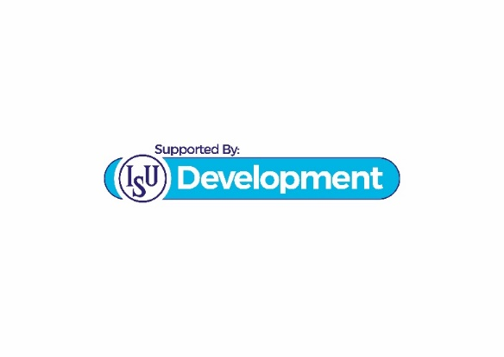  E-mail: daniel.wende@eislauf-union.de | 